Project Untuk Melatih Skill Full Stack Developer

* Beginner level

1. Membuat Program kalkulator

Algoritma

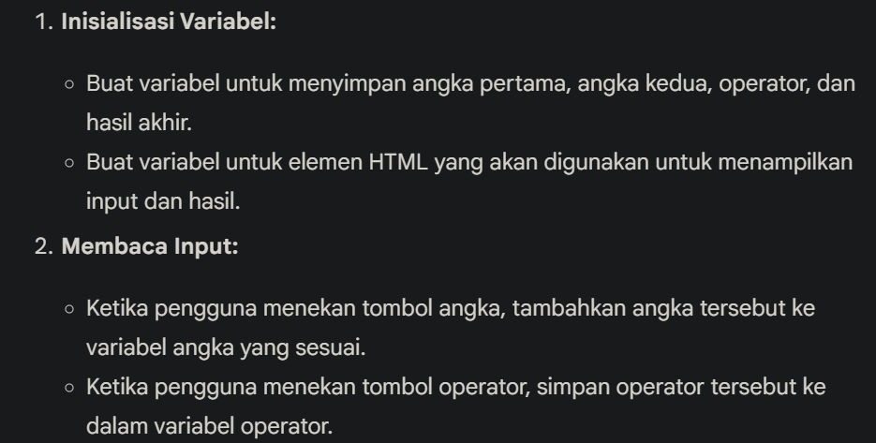

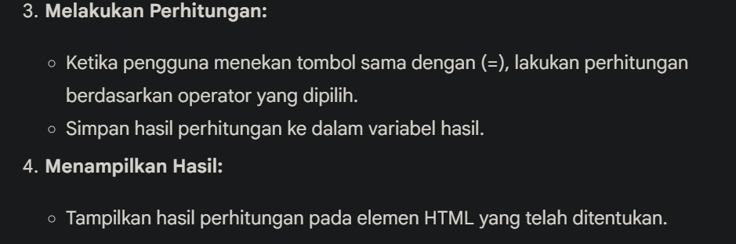

1. Personal portopolio website

Personal portopolio adalah wadah yang menampung ringkasan tentang diri kita, pencapaian kinerja, hard skill maupun soft skill yang kita miliki. Dalam kata lain portopolio harus mecakup kepribadian, kreativitas dan penguasaan teknik. Personal portopolio diantaranya :

* Untuk memberikan gambaran pada client mengenai kita
* Menjadi dokumentasi mengenai diri kita

Elemen-elemen portopolio personal:

1. Data-data diri (seperlunya) disertai dengan foto profesional
2. pendidikan
3. Skill (hard & soft skill)
4. Pengalaman
5. Pencapaian

Tekhnologi yang akan di pakai:

1. Tailwindcss
2. Web browser(google chrome)
3. Text editor(VSCode)
4. Simple blog platform
5. To-Do list app
6. Weather app
7. URL shortener
8. Basic E-commerce website
9. Recipe sharing platform
10. Contact manajement system
11. Quiz app
12. Personal budget tracker
13. Calculator

* Intermediate level

1. Social media dashboard
2. Real time chaat app
3. Task manajement system
4. Multi user blog with comments
5. Event manajement system
6. File upload and sharing system
7. Job board platform
8. Online learning platform
9. Booking system for appointments
10. Content manajement system

* Advanced level

1. E-commerce platform with payment integration
2. Real time collaborative text editor
3. SaaS subscription platform
4. Project manajement tools
5. Blogging platform with full text search
6. Real time notification system
7. Multi tenant app
8. Vidio straming service
9. Real time analyst dashboard
10. EENTER{RISE Resource planning(ERP) system

* Expert level

1. AI-Powered content recommendation engine
2. Blockchain based voting system
3. Full scale social media platform
4. Multi language support platform
5. IoT dashboard with real time data
6. High performance E-commerce with microservices
7. Prograssive Web App (PWA) with offline support
8. Serverless fullstack app
9. Real time collaboration platform
10. AI-Powered personal assistant platform